A 1960s Arkansas Bungalow Gets a Cinematic Glow-Up | Architectural Digest

Brigette Muller 560-Square-foot NYC Apartment

Jenna Lyons’s Kitchen Has the Best Fridge Camouflage

Modern Mediterranean Kitchen Reveal - Jenna Sue Design

Kitchen of the Week: A 1700s Cookspace in Hastings on Hudson, Inspired by a Painting - Remodelista

Undermount Sinks Guide: The Ultimate Guide

Interior Design Portfolio by Katherine Thewlis — Hausmatter

ARTICLE AIRBNB

—------------------------------------------------------------------------------------
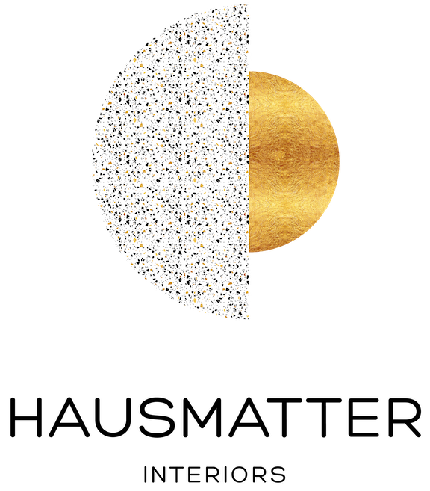
I was so thrilled to collaborate with InsidEast and their stunning, solid brass faucets. You guys, the quality cannot be beat. These are heirloom quality pieces and it feels so special - almost like jewelry.

https://www.hausmatter.com/blog/2020/9/22/snake-bathroom-reveal
Logo : https://images.squarespace-cdn.com/content/v1/5c2bbe344eddecdc6f4b6e9e/c1650157-b1d9-419f-8b7a-64cd14aec40b/main-logo-transparent.png

https://www.instagram.com/hausmatter/p/CFilxNln2D3/

—------------------------------------------------------------------------------------
remodelista
The brass faucet and sprayer are from Insideast Designs. “I love to collect vintage objects, so when it came time to style the kitchen, I had a field day deciding where to put beloved treasures like my royal Copenhagen tea set and my Nan’s arched brass mirror. The kitchen didn’t feel complete to me until I styled the open shelves and placed my grandfather’s painting in its rightful spot.”
Logo : https://cmsmedia.remodelista.com/wp-content/uploads/2017/11/logo-remodelista-large-new-upload.svg
https://www.remodelista.com/posts/and-north-emma-tuccillo-kitchen-renovation-hastings-on-hudston/


I sourced the most reasonably priced raw brass bridge faucet and pot filler I could find on Etsy.
https://www.jennasuedesign.com/modern-mediterranean-kitchen-reveal/
Jenna Sue • Design + DIY 521K
https://www.instagram.com/reel/Chhc_UDglor/

I spent months searching for the right faucet, pot filler, knobs and appliance pulls for this kitchen. I came up short trying to find fixtures that all coordinated, and didn’t look/feel like cheap gold.

Ultimately, I chose unlacquered (raw) brass which was a bit more of an investment, but I think it was the right call for the style of this kitchen.

There’s quite a few reasons this finish is a designer favorite:

▫️ a timeless, classic finish
▫️ adds character and warmth
▫️ develops a patina over time
▫️ can easily restore to its original shine
▫️ it’s naturally antibacterial
▫️ will not rust
▫️ it’s a universal finish—you won’t have to worry about matching fixtures!

I ordered my faucets from @insideastdesigns, and the knobs and pulls from a few different sources. I’ll link to them all now in my stories.

If you have raw brass fixtures in your home, how do you feel about them? Any regrets? 👇🏼

—------------------------------------------------------------------------------------

https://www.lightcookie.com/
https://www.instagram.com/light_cookie/
https://www.instagram.com/light_cookie/p/BzvBZLrIc4f/

—------------------------------------------------------------------------------------

https://www.abigailtreedesign.com/
Abigailtreedesign
Timeless Interior Design
“This faucet makes the tiny powder room pretty great.“
https://www.instagram.com/abigailtreedesign/p/CAVvu53HYjU/

—------------------------------------------------------------------------------------

https://www.instagram.com/booshbamf/p/B7SP1T8jmRn/?img_index=1

—------------------------------------------------------------------------------------

https://www.instagram.com/thetreehouse_onthehill/p/CHGr0w5HZ13/

—------------------------------------------------------------------------------------

Ciarakenaston
https://www.instagram.com/ciarakenaston/p/CEmVLK7BVaL/
https://www.instagram.com/ciarakenaston/p/CHbeBYPBAf-/
https://www.instagram.com/ciarakenaston/p/CKKHFLJhG1H/

—------------------------------------------------------------------------------------
https://www.airbnb.com/rooms/47157692
Blue Cabin
https://www.instagram.com/bluecabin.ny/p/CGGj2kUnWHa/

—------------------------------------------------------------------------------------

Davenport Design
https://www.designdavenport.com/
https://www.instagram.com/davenport_design/p/CJJVhH4sesN/
https://www.instagram.com/reel/CvufbqIgQik/

—------------------------------------------------------------------------------------

https://www.instagram.com/rae.interiors_/
interior design

https://www.rae-interiors.com/
https://www.instagram.com/rae.interiors_/p/CJG_aRzMEcD/

—------------------------------------------------------------------------------------

https://www.airbnb.com/rooms/43915356

https://www.instagram.com/onriversbend/p/CGfN4jKgCWs/?img_index=1

—------------------------------------------------------------------------------------

Interior design
Callie Blanks | Houston Interior Designer
https://www.callieblanksinteriors.com/
https://www.instagram.com/callieblanks.interiors/p/CKb9lJ0rEtg/

love the antique style of @insideastdesigns handmade plumbing fixtures.

—------------------------------------------------------------------------------------

Interior Design Studio
https://www.studiokdesignhouse.com/
https://www.instagram.com/studiok_design/p/CKSXmwsMzul/

—------------------------------------------------------------------------------------

https://theeleganteconomist.com/
https://www.instagram.com/elisabethcolette/p/CKPP2j2FOxc/

—------------------------------------------------------------------------------------

https://www.carleysummers.com/
Interior Design
https://www.instagram.com/carlaypage/p/CLPVCVDr94n/

—------------------------------------------------------------------------------------

https://mdlf-id.com/
mollydelafalaise
Interior Design
Handmade accents in living finishes and rich textures keep this all white kitchen I designed from feeling cold.
https://www.instagram.com/mollydelafalaise/p/CLArTzDJJxS/

—------------------------------------------------------------------------------------
https://greendoorhomes.com/
Real Estate Solutions Company
https://www.instagram.com/greendoorhomes/p/CKnExiMh-vq/

—------------------------------------------------------------------------------------

Brandi Russell
Home projects
https://www.instagram.com/blrnyc/p/CNImWQ0n8AF/?img_index=4

—------------------------------------------------------------------------------------

https://theeleganteconomist.com/
https://www.instagram.com/elisabethcolette/p/CMXQbNjFQxZ/?img_index=7
https://www.instagram.com/elisabethcolette/p/CNFoRQPlL2L/

—------------------------------------------------------------------------------------
https://www.instagram.com/lifebehindtheredfrontdoor/p/COKreC2LuOY/

* Ornate tap!! *

Did you ever see such a beautiful wall mounted bath tap!?! So pretty!!

The same can not quite be said for the actual bathroom at the moment which is still a buillding site and very much a work in progress!!

We love the gold fittings in the en-suite so much for are following suit for the main bathroom!!

I love all the sourcing and this was a particularly great find from @insideastdesigns on @etsy
We can’t wait to see them fitted over the freestanding bath!!

https://www.instagram.com/p/CcjJkyeKXof/
https://www.instagram.com/p/CTuBvLer4JQ/

—------------------------------------------------------------------------------------

https://cedarandstonefarmhouse.com/
https://www.instagram.com/cedarandstonefarmhouse/p/CNhwkBwhJuU/

—---------------------------------------

Interior Design Studio

https://www.christen-danielsinteriors.com/
https://www.instagram.com/christendanielsinteriors/p/CO0jFUhNcTk/

—---------------------------------------

https://www.arcadianrevival.com/
Bethanybowyerkhan
https://www.instagram.com/bethanybowyerkhan/p/CPIllgTrByf/

—---------------------------------------

Interior Design Studio

https://augustinteriorsstudio.com/
https://www.instagram.com/augustinteriorsstudio/p/CRU7lWYpyaT/

—---------------------------------------
Woodworker// Designer
https://www.instagram.com/thisnewoldhome/p/CQzJ2eajYso/

—---------------------------------------
Interior.design
https://www.instagram.com/mike_turnerr_/p/CQwtbr2tZLM/

—---------------------------------------
www.airbnb.com/h/dahliahouseomaha
https://www.instagram.com/p/CR2CznJsK6d/
https://www.instagram.com/p/CXqylUlLiFe/
My love affair with this faucet is a long story but we’re living happily ever after. It’s made in Morocco by a company called @insideastdesigns. It’s unlacquered brass so it has no protective coating. Over time the brass will darken and patina and show wear. It's relatively low-maintenance if left alone to age. This living finish may not appeal to everyone, but it's great for someone who likes to watch things age gracefully. We have a lot of living finishes in the house that will show more character over time. ✨

—---------------------------------------
Interior Design
https://www.verplankavedesign.com/
https://www.instagram.com/p/CRW25DqFZu-/
https://www.instagram.com/p/CYjti3HBH89/

—---------------------------------------
Design architecture
https://www.instagram.com/the_style_hedonist/p/CSxK6EOJvEa/

—---------------------------------------
Nicole Dianne - Interior Photographer
https://www.instagram.com/nicolediannephoto/p/CSw1G32lKXj/

—---------------------------------------
jennalyonsnyc
862K
Partner at Fundamentalco
https://www.instagram.com/jennalyonsnyc/p/CSwt3CFlmZE/

—---------------------------------------

rebeccaandgenevieve
Valeria Jacobs
604K
https://www.instagram.com/p/CS7UCZSvvlS/

—---------------------------------------

https://carolineturner.co/
Interior Design Studio
Caroline Turner
https://www.instagram.com/p/CTSxPz0LdtB/

—---------------------------------------
Interior Design Studio
www.erynlambertdesign.com
https://www.instagram.com/p/CUrBPLrrFsk/

—---------------------------------------
•full service interior design studio•
https://www.willandblu.com/
https://www.instagram.com/p/CVskpB1LXrO/

—---------------------------------------
inné concept studio
https://www.instagram.com/p/CVyv2fdMrLy/

—---------------------------------------
https://hydrangeatreehouse.kit.com/
hydrangea treehouse
https://www.instagram.com/p/CWV7ghLrtw5/

—---------------------------------------

Riad Tile
236K
Shopping & retail
https://riadtile.com/
https://www.instagram.com/p/CXOy59COhXQ/

—---------------------------------------

Article happy customer / good story / good content

https://covehouse.co/
Entrepreneur 9k /

Ordered some beauties from @insideastdesigns for all faucets & showers + tubs. Can’t wait to see them come to life. https://www.instagram.com/p/CYFKUGmPOyA/
https://www.instagram.com/p/CgXHcl0rrV0/
We loved the aged brass @insideastdesigns with this sympathetic green meets beige color.

https://www.instagram.com/reel/CgPw6XhFtzx/

The @insideastdesigns fixtures are the perfect complement and will patina with age. 🙏🏻
https://www.instagram.com/reel/CgCrPO2pLHA/

We have a love affair with this @insideastdesigns Unlacquered Brass Bridge Faucet. This is a living finish that develops patina over time and feels like a timeless addition to the #casavista kitchen.
https://www.instagram.com/reel/Cfkr-r3lADw/

https://www.instagram.com/p/Ce9E67oliF_/
https://www.instagram.com/reel/Ce12rlMhGbq/
https://www.instagram.com/reel/Cd_v1d4lqQJ/

—---------------------------------------
Interior Design Studio

Marissa Whitley Tago
16.4K
https://www.thewhitleycompany.com/
https://www.instagram.com/p/CYhI869rDFT/

—---------------------------------------
Interior Design Studio
Marina Ramain | Interior Designer 🇫🇷🇬🇧🇩🇪
www.atelier-ramain.com
https://www.instagram.com/p/DS2SBE_CKPF/

—---------------------------------------
Interior Designer
Angelica Centeno
https://www.atelierac.co/
https://www.instagram.com/reel/DPPFLoVDq9A/
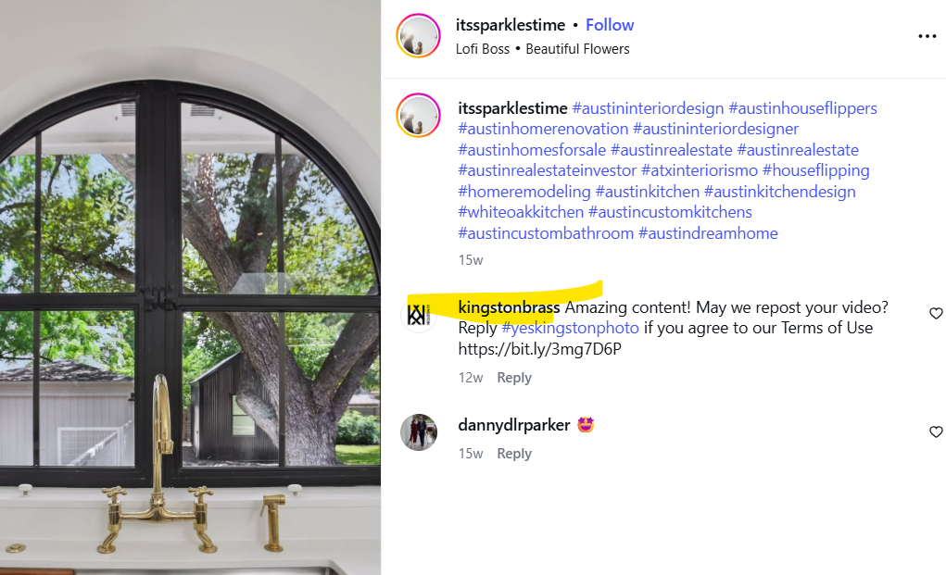
you don't react with tags

—---------------------------------------
https://stayhomestyle.blog/
Ashley Whatley
Thoughtful design
https://www.instagram.com/p/DPKpus4DM26/

—---------------------------------------
Catskill Cabin in the Woods
https://www.instagram.com/p/DPCq0IpCBEj/
https://www.instagram.com/reel/CqVZEXwKK1G/
https://www.instagram.com/reel/Cm6q421ofbB/
https://www.airbnb.com/rooms/45618798

—---------------------------------------
Interior Design Studio
Mattye Dewhirst
https://www.mattyedewhirst.com/
https://www.instagram.com/p/DO_9ncMD1tX/

—---------------------------------------
Interior Design Studio
Michael Mezzano Design
https://www.michaelmezzano.com/
https://www.instagram.com/p/DN0qMGVxKKb/

—---------------------------------------
Interior Design
Ana Rose
24k
https://www.anarosestudio.com/
https://www.instagram.com/p/DMlB9YcKKm4/

—---------------------------------------
Interior Design Studio
https://chefandcabinet.com/
https://www.instagram.com/p/DL809MttSgW/

—---------------------------------------
Interior Design Studio
Tanya Stone 12k
https://www.instagram.com/p/DJ4mVRWPRBF/
https://tanyastoneinteriors.com/
Creating custom furniture and decor has become a true passion of mine in this industry. My journey from initially not even knowing what a cinder block was, to self-educating about materials, drawings, renderings, layouts, and architecture has been incredibly humbling and rewarding. Cheers to more growth and more design!
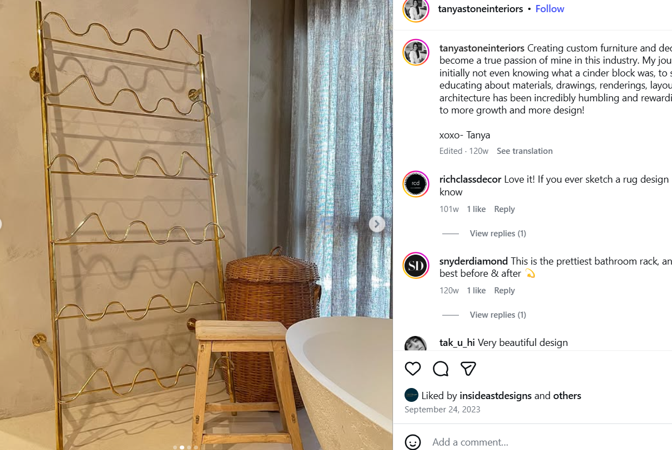
Custom design / story
https://www.instagram.com/p/CxlY66_Pffa/

—---------------------------------------
interior style
Elizabeth Brooks
472K
https://homeinthehemlocks.com/
https://www.instagram.com/p/DImXk-gRc-t/

—---------------------------------------
casachiquita.cr
https://www.airbnb.com/rooms/1299398815382735789
https://www.instagram.com/p/DHK-OV-I0Jf/

—---------------------------------------
Vermont Interior Design
https://www.vtinteriordesign.com/
https://www.instagram.com/reel/DGBEgk3u67X/

—---------------------------------------

Renovations & Extensions in London
https://www.the-page.co.uk/
https://www.instagram.com/p/DF8QR8pCu7X

—---------------------------------------
Interior Design Studio
https://www.elliottmeyersdesign.com/
https://www.instagram.com/p/DFOCsnEpI5O/

—---------------------------------------
bigwaveplumbing
David Hay
https://www.instagram.com/reel/DDSsFVTTH9v/

—---------------------------------------
Sol at Sisters Beach - Airbnb
airbnb.com/h/solatsistersbeach
https://www.instagram.com/p/DCS81vrvvZP/?img_index=4

—---------------------------------------
Interior Architecture - New York
https://www.evidenceofthings.com/
https://www.instagram.com/p/DBd5HtZRCnj/

—---------------------------------------
Jacumba Hot Springs Hotel
69.4K
Hotel resort california
https://www.instagram.com/p/C_I-0OMRxJx/
https://www.instagram.com/p/CyV7b21ugpu/

—---------------------------------------
Julie Mood | Design
https://juliemood.com/
https://www.instagram.com/p/C-AiEs-u9sa/

—---------------------------------------
c h r i s t i n e d o v e y
28.6K
https://www.airbnb.ca/rooms/1065269703782685883
https://www.instagram.com/reel/C9w5BcbRsy9/

—---------------------------------------
Tanisha Cannings
Interiors Enthusias
https://www.instagram.com/reel/C9nSDNTgDsv/

—---------------------------------------
Interior Design Studio
B Y R D S T U D I O
by.byrd
10.3K
https://www.byrd.studio/
https://www.instagram.com/p/C7ZI9mXMNdb/
https://www.instagram.com/p/C7Ray7cuIZP/
https://www.instagram.com/p/CeEIGAjM5jO/

—---------------------------------------
Home decor
https://theflippingvintage.com/
144K
https://www.instagram.com/p/C683UoNunrp/
https://www.instagram.com/p/Co4sflar-Gl/

—---------------------------------------
https://www.instagram.com/p/C4JHE2JPc0r/
Interior Design Studio
https://www.littlebylittleinteriors.com

—---------------------------------------
mariam grace design
https://mariamgracedesign.com
https://www.instagram.com/reel/C38pY5cyTXj/

—---------------------------------------
Brittany Swigart | AZ Interior Designer
16.8K
https://www.instagram.com/p/C2h3gRvOFa3/
https://www.instagram.com/p/C3MIdJUrwH8/
https://www.maevedesigncollective.com/

—---------------------------------------
Liv Alliston Design
www.livallistondesign.com
https://www.instagram.com/p/C2YTnibPrOC/
I’m in love with the this Victorian, brass bridge faucet from @insideastdesigns. It’s weighty and stunning and plays off of the yellow veining in the quartzite slab. Definitely a feature of the kitchen ☺️

—---------------------------------------
Mallori Hanes | Restoring my dream home
wilsonwaddillhome
29k
https://www.instagram.com/reel/C0Po4iTuGn5/
Brb I will be staring at my tub filler from @insideastdesigns for the rest of the day!

—---------------------------------------
https://www.renewhomesc.com/
Renew Home | Home Renovations
https://www.instagram.com/reel/CzbfVtouey4/

—---------------------------------------
Long Canyon Studios
https://www.instagram.com/p/Cy4O6ylJkJn/
https://www.airbnb.ca/rooms/869495747832308289

—---------------------------------------

Michael Carron
Interior Designer and Stylist
https://voila.love/michaelcarrondesign
https://www.instagram.com/p/Cw2reyEOPh3/

—---------------------------------------
Top pictures / clean account / brand
https://www.instagram.com/p/Cwnx6V8REEs/
https://www.icdtstudio.com/

—---------------------------------------
𝐂 𝐎 𝐔 𝐍 𝐓 𝐑 𝐘 𝐂 𝐎 𝐓 𝐓 𝐀 𝐆 𝐄 𝐑 𝐄 𝐍 𝐎 𝐕 𝐀 𝐓 𝐈 𝐎 𝐍
6k / Interior Designer
https://www.instagram.com/p/CwCtFAPr0mt/
Very Good pictures

—---------------------------------------
https://www.roselakedesign.com/
Interior Design Studio

https://www.instagram.com/p/Cvh0Iw7LP5Z/

—---------------------------------------
https://andnorth.com/
https://www.instagram.com/reel/CvgHUR-Axok/
59k

—---------------------------------------
https://localshadestore.com/
https://www.instagram.com/reel/CviXhywL0vu/

—---------------------------------------
https://www.instagram.com/p/CvAl0L4rJ8E/
https://www.larapindesign.com/
creative studio

—---------------------------------------
Brand / clean / good pictures
https://www.casanguilla.com/
Casanguilla / Italia
https://www.instagram.com/p/CuY37fsoW_A/
https://www.instagram.com/p/Cud_zWPIyFT/

—---------------------------------------
Elliss Eyre / Home Improvement / portugal

“we love our handmade brass taps from the wonderful @insideastdesigns 💛 The patina is looking 👌🏼🍯”

https://www.instagram.com/p/CuJkDZHMC9Z/
Good pictures / Good video product / shower
https://www.instagram.com/p/CuMEJhBs5l8/
https://www.instagram.com/p/CuHTl54M8KQ/
https://www.instagram.com/reel/Cu9a2XBo5Ze/
https://www.instagram.com/reel/Cto8Sf7utaI/
https://www.instagram.com/p/Cp2KXpNtppY/

—---------------------------------------
STORY OF HAPPY CUSTOMER (HOW MANY TIMES / PRODUCT)
Hooperhomesteading
Shane Hooper
Family of 6
1800s Farmhouse Project

Good videos product
https://www.instagram.com/reel/CuEyN7YRf6c/
https://www.instagram.com/reel/Cqk15P-sfFZ/
A simple photo to update you on our beautiful brass faucet... the patina is so lovely! Enjoying the wildflowers and the spring like sunshine filling our old farmhouse kitchen.
Do you have a favorite wildflower?? And can anyone tell me what these are? Still trying to find them. And yes that’s still our moroccan Zellige handmade tile just hanging out propped up against the wall... add that to the to do list. ☺️
https://www.instagram.com/p/CpqMbs2JkK2/
https://www.instagram.com/reel/Cjs3N7dPz1G/
https://www.instagram.com/reel/C6GyB_lLGgq/
https://www.instagram.com/reel/CuNnrqMJJ2g/
https://www.instagram.com/reel/Ci5d4UypCOP/
https://www.instagram.com/reel/CiVXY3VsYwb/
Our unlaquered brass faucet is already showing a beautiful aged patina! Even though we still have work to finish in our old farmhouse kitchen...(touch up paint, backsplash, trim) I walk in and all I see is this timeless beauty!
مقال يجمع جميع المعلومات عن هذا الزبون من فيدوات و صور على شكل قصة زبون / صور و فيدوات جميلة
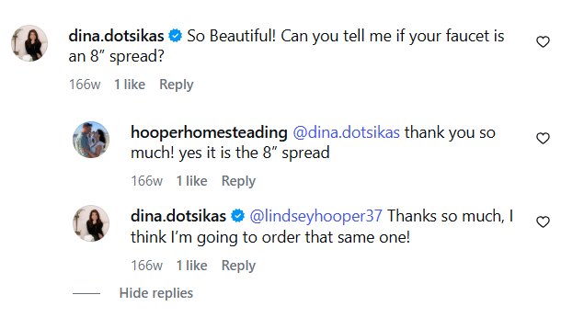
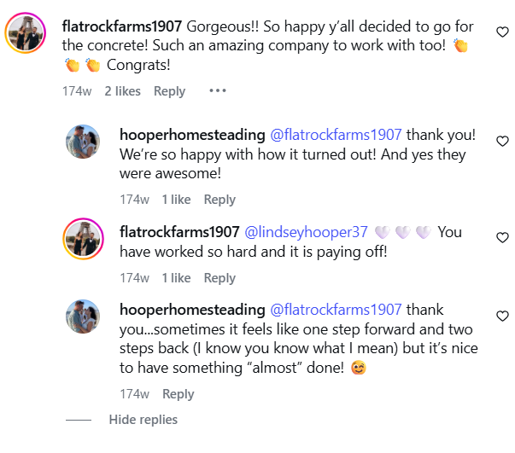

—---------------------------------------
صور جيدة للمنجات لكن محتوى لمؤثين شواذ / كيف يمكن الاستفادة من الصور؟
https://www.instagram.com/p/Ct9u9N3v7yi/

—---------------------------------------
With_my_four_sons
GOOD FOR productS PICTURES / VIDEOS
https://www.instagram.com/reel/CsjYUdIJC0U/
https://www.instagram.com/reel/C6H7hdpMXLm/

—---------------------------------------
https://www.kembarnosara.com/
Airbnb / costarica

Thanks to our friends @insideastdesigns for creating these Custom made brass shower faucets all the way from Morocco.
Making this space extra 🤌🏻🤌🏻

https://www.instagram.com/p/CrCD8Ikuwvt/

Loving our custom made brass shower faucets from Morocco. @insideastdesigns

—---------------------------------------

lessmeansmoreproject

https://www.instagram.com/p/Cq3yPXaOyng/ Goodp pictures

—---------------------------------------

cleanlivingvibes
Holly Brandon
https://www.instagram.com/reel/CqilsGzjFZ9/
Good videos

—---------------------------------------
Lacey Holdsworth
https://www.oakandarrowinteriors.com/
Interior Design Studio

https://www.instagram.com/reel/CpdbV_yjTdz/

—---------------------------------------
https://tapiahomeco.com/
Mariah Tapia 126k
Design
https://www.instagram.com/p/CpJ2k-jNmMc/
https://www.instagram.com/reel/Cp1izWhD5Jl/
Having unlacquered brass in our kitchen has been a DREAM of mine. It’s a stunning brass that in my opinion, only gets better as it ages.
It is a bit of an investment BUT, it’s a good investment if you’ve saved and KNOW it’s exactly what you want.
Let me tell you why I chose unlacquered brass in the new house

👉🏼 Develops a patina over time
👉🏼 It will never rust
👉🏼 Its has a warm rich depth
👉🏼 It’s classic and timeless
👉🏼 You can always restore it back to its original shine
Tomorrow, I add all the unlacquered hardware to the cabinets and then the kitchen will be complete.
Comment “brass links” below for an instant link to shop
Faucet & Pot filler: @insideastdesigns

—---------------------------------------
Missy Farmer
Taking a moment to appreciate and enjoy this space, even if it’s not finished 😅. One of my favorite pieces in our master suite are these gooseneck faucets from @insideastdesigns . They are stunning, and have already started to patina beautifully. I did a ton of research, and Abdel had the best prices, and has been so wonderful to work with. I was nervous ordering from Etsy and overseas, but it’s been a great experience, and I couldn’t love them more 🥰
https://www.instagram.com/reel/CoKln7Eu7Q7/
https://casadefarmer.com/

—---------------------------------------
Macie || Custom Builds & Interior Design
When all of the details and decisions start coming together. ✨
https://www.instagram.com/p/CkwhXmULWCn/
https://www.instagram.com/reel/CgEkiOZl74e/

—---------------------------------------
https://zelligesimulator.com/
popham design 115k
Home decor
https://www.instagram.com/p/Ckdjia7t7_t/
we love these brass fixtures from @insideastdesigns !

—---------------------------------------
Kaley Cutting / ourvintagevictorianhouse
https://www.instagram.com/reel/Cj5a3siDqXq/
Hey guys I am so excited to share the finishing touch to our kitchen facelift and it is this stunning brass faucet and sprayer from @insideastdesigns If you guys couldn’t tell by the chandeliers and accents around our home I am a huge brass fan and I knew this would be the perfect addition to the space. Their pieces are 100% brass and are made in Morocco! And they create so much more than just faucets! They have an amazing collection of sinks, shower systems and hardware too! I’m just so in love and I couldn’t wait to share the shop with you guys make sure to head over and check it out for yourself! Use code KALEYC40 for $40 off orders over $200.

—---------------------------------------
Brooke | Amelia Design
Digital creator
interior design
This home has so many unique features like the faucet and potfiller, they were custom made from an artisan in Morocco!
https://www.instagram.com/reel/CjZMWM6vxOz/

—---------------------------------------
france
La Maison de L’Arche
Vacation Home Rental
https://www.instagram.com/p/Ciw2ZgdqKLU/
Quelle merveille ! Contempler du bel artisanat c’est comme admirer une oeuvre d’art et à chaque fois que l’on s’attarde sur ce meuble vasque et son robinet pont, on est sous le charme.

—---------------------------------------
Canada
https://www.instagram.com/reel/ChSS52XAZn5/
39k - Sabine Pajkovic - Design, Interiors, Decor

—---------------------------------------
Melissa Wilson | Design & DIY 60.7K
https://www.patinamaison.com/
https://www.instagram.com/reel/ChHyyAPFpnh/
https://www.instagram.com/reel/CfMMvWRFWNP/

—---------------------------------------
madelynn hudson
270k
Interior Design Studio

https://www.instagram.com/reel/Cgf0Zy9ln1a/

—---------------------------------------
Artist
Sarah Klieber
Custom + Local Art by Sarah Klieber
https://www.instagram.com/p/Cfbd5c_uWVh/
https://www.instagram.com/p/CYcK9a1LBus/
https://www.instagram.com/p/CZP05-7JYQc/

—---------------------------------------
italy
Maria Angela Cavazzini
ARCHITETTURA & INTERIOR DESIGN
https://www.studiocavazzini.com/
https://www.instagram.com/p/CfUmKKUNKmX/

—---------------------------------------
Willowplacefarm
Mica | Willow Place Farm
https://www.instagram.com/reel/CfNr1O7lEDK/

—---------------------------------------
Texston Industries
https://www.instagram.com/p/CfCdmttPv8u/
https://www.texston.com/

—---------------------------------------
Feller.house 16k
Savannah Feller
https://www.instagram.com/p/CfCcCNiupt-/

—---------------------------------------
Flatrockfarms1907 - 175k
Cam & Jen | Flatrock Farms
https://www.instagram.com/reel/CejiTxBDwc7/
https://www.instagram.com/reel/CdhFawaDm-T/

—---------------------------------------
Happy customer / good video
Kate Jenni
I scoured the internet and was so excited to come across @insideastdesigns! Handmade in Morocco, their products are beautiful, customer service has been amazing and I can’t wait to see these pieces (and some others) in our home. I can’t recommend them enough so far.
https://www.instagram.com/reel/CeiykhzDRd5/

—---------------------------------------
Montage video product
https://www.instagram.com/reel/CeWWkSdIhH_/
Jade Zammit Stevens | personal blog 60k

—---------------------------------------
The.wolf.academy
https://www.instagram.com/p/CahZcl_O9R5/
https://www.instagram.com/p/CapI0n0uw0U/
The sink faucet, shower handles, and shower head are all from @insideastdesigns, and I love how they look.

—---------------------------------------
nickyrisingltd
N i c k y R i s i n g L t d
Collector and stylist
Well we all know I love fabrics, but it’s expanding to faucets! Look what just arrived from my favourite city Marrakech. Absolutely stunning and perfect for my new beach duplex project!!
https://www.instagram.com/p/CaakwfmPsft/

—---------------------------------------
boxwoodandspruce
Digital creator 53k
Each and every one I use and love in our very own home! (Like this gorgeous shower system from @insideastdesigns) So keep swooning brass lovers! It’s no longer so far out of reach!
https://www.instagram.com/reel/CZLLa8Nq8Yp/

